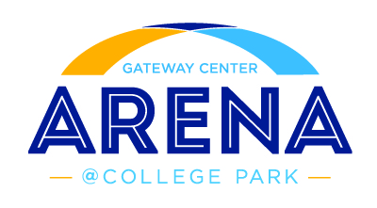

VENDOR REGISTRATION FORM
Please fully complete the registration form and attach all documentation Business Name (as it appears on business license):

Business Address: ST.

Confirm the required forms are attached to your registration form:
Provided a formal letter of request [ ] Yes [ ] No Copy of Current Business License: [ ] Yes [ ] No
Zip

Serve Safe Certification (Must be approved by State of Georgia) [ ] Yes [ ] No Current Menu and proposed ARENA menu with pricing [ ] Yes [ ] No Picture of Portable Stand (what you currently use or plan to use. List power
requirements & dimensions)
Provide below a brief history of your business (if additional space is needed please attach).

You may email your Request for Consideration to jcausey@gicc.com or deliver Attn: Jason Causey GICC 2000 Convention Center Concourse Admin Offices (rear entrance) College Park, GA 30337

